company_size
SME 0.493635
Startup 0.495987
Enterprise 0.707790
Name: high_adoption, dtype: float64

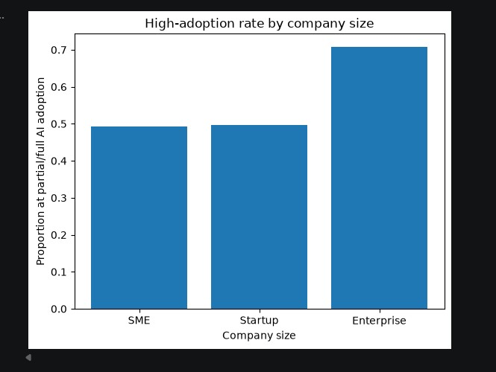
ai_adoption_rate ai_maturity_score \
ai_adoption_rate 1.00 0.84
ai_maturity_score 0.84 1.00
ai_training_hours 0.73 0.82
ai_budget_percentage 0.74 0.82
productivity_change_percent 0.67 0.74
employee_satisfaction_score 0.33 0.38
revenue_growth_percent 0.41 0.40

ai_training_hours ai_budget_percentage \
ai_adoption_rate 0.73 0.74
ai_maturity_score 0.82 0.82
ai_training_hours 1.00 0.56
ai_budget_percentage 0.56 1.00
productivity_change_percent 0.63 0.60
employee_satisfaction_score 0.34 0.31
revenue_growth_percent 0.35 0.34

productivity_change_percent \
ai_adoption_rate 0.67
ai_maturity_score 0.74
ai_training_hours 0.63
ai_budget_percentage 0.60
productivity_change_percent 1.00
employee_satisfaction_score 0.29
revenue_growth_percent 0.48

employee_satisfaction_score \
ai_adoption_rate 0.33
ai_maturity_score 0.38
ai_training_hours 0.34
ai_budget_percentage 0.31
productivity_change_percent 0.29
employee_satisfaction_score 1.00
revenue_growth_percent 0.16

revenue_growth_percent
ai_adoption_rate 0.41
ai_maturity_score 0.40
ai_training_hours 0.35
ai_budget_percentage 0.34
productivity_change_percent 0.48
employee_satisfaction_score 0.16
revenue_growth_percent 1.00
Strongest absolute correlation: ('ai_adoption_rate', 'ai_maturity_score') 0.84

Adoption rate by company size (bar chart) — Enterprise companies land in "partial or full" adoption 70.8% of the time, versus ~49–50% for SMEs and startups. Company size is a genuinely strong driver here — enterprises adopt at a rate about 1.4x higher than smaller companies, not just a marginal difference.

